Millay, Edna St. Vincent (1892-1950)

Edna St. Vincent Millay was a poet, playwright, and free-spirited bohéme who epitomized the aesthetically and sexually adventurous ‘new woman’ of the early twentieth century. Born in Rockland, Maine and raised by an unconventional mother who encouraged her intellectual and artistic pursuits, Millay achieved national attention at the age of nineteen with her lyric poem Renascence (1912). Millay’s innovative poetry, for which she received a Pulitzer Prize in 1923, integrated conventional forms with unconventional content that celebrated sexual liberation and female autonomy.

Her whimsical verse plays The Princess Marries the Page (c. 1915), Two Slatterns and a King (c. 1915), and The Lamp and the Bell (1921) similarly evoke traditional genres to challenge conventional gender roles and sexual morality. After graduation from Vassar College in 1917, Millay moved to Greenwich Village, where she found an artistic home as an actress and playwright with the Provincetown Players. Her most notable dramatic success came with their 1919-20 production of her anti-war fable Aria da Capo, a satirical and reflexive re-visioning of commedia del arte’s Columbine and Pierrot as Greenwich Village bohemians. Their witty harlequinade is interrupted by a tragical-pastoral interlude in which two greedily territorial shepherds kill each other. The harlequinade resumes, but with the bodies of the two shepherds remaining on stage. During the next two decades, Millay continued to write and perform her poetry, also completing a number of short stories (under the name Nancy Boyd), an opera libretto (1927), a translation of Charles Baudelaire’s Flowers of Evil (1936), and the genre-defying poetic drama in blank verse Conversation at Midnight (1937).

List of Works

Millay, Edna St. Vincent. (1956), Collected Poems, ed. Norma Millay, New York: Harper and Bros.

----- (1926) Three Plays, New York: Harper and Bros.

References and Further Reading

Cheney, Anne. (1975) Millay in Greenwich Village, Tuscaloosa: University of Alabama Press.

Edna St. Vincent Millay Society, http://www.millay.org/.

Milford, Nancy. (2001) Savage Beauty: The Life of Edna St. Vincent Millay, New York: Random House.

Thesing, William B., ed. (1993) Critical Essays on Edna St. Vincent Millay, New York: G.K. Hall.

Cheryl Black, University of Missouri

Recommended Illustrations



Edna St. Vincent Millay, c. 1914
[Photo by Arnold Genthe, Library of Congress: http://www.loc.gov/pictures/item/agc1996000362/PP/]

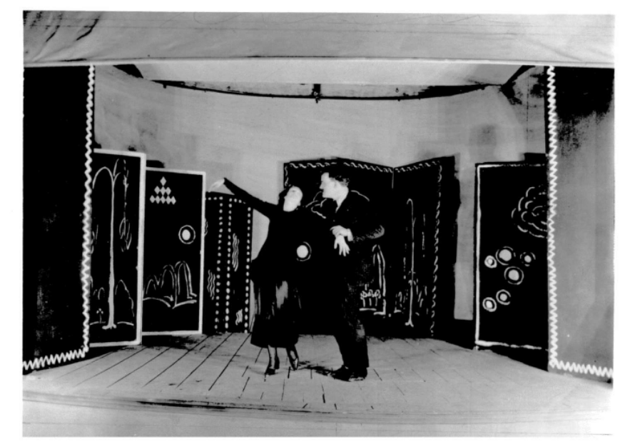

Aria da Capo in rehearsal at the Provincetown Playhouse, 1919
[Source: Billy Rose Theatre Collection, New York Public Library, Lincoln Center]

